Student Stories

Showcase of minimum 3 testimonials from students.
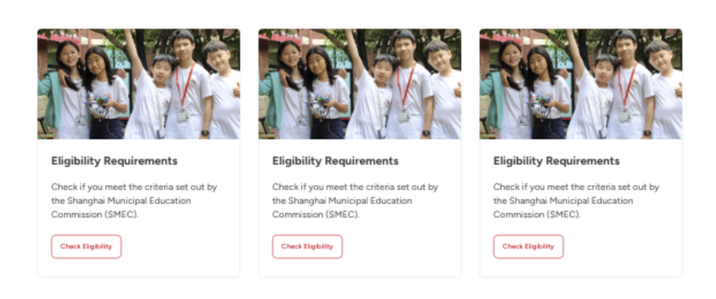

No. | Article Title | URL
1. | 'Top in World' for Additional Maths | https://suzhou.dulwich.org/dulwich-life/top-in-world-for-additional-maths
2. | Perfect Score in IBDP | https://suzhou.dulwich.org/dulwich-life/ryan-g-achieved-a-perfect-score-in-ibdp
3. | Road to Cambridge | https://suzhou.dulwich.org/dulwich-life/student-spotlight-lark-z-class-of-2023-road-to-cambridge

Display community scroller focusing on happy students – minimum 6 students (2 DUCKS, 2 JS, 2SS)
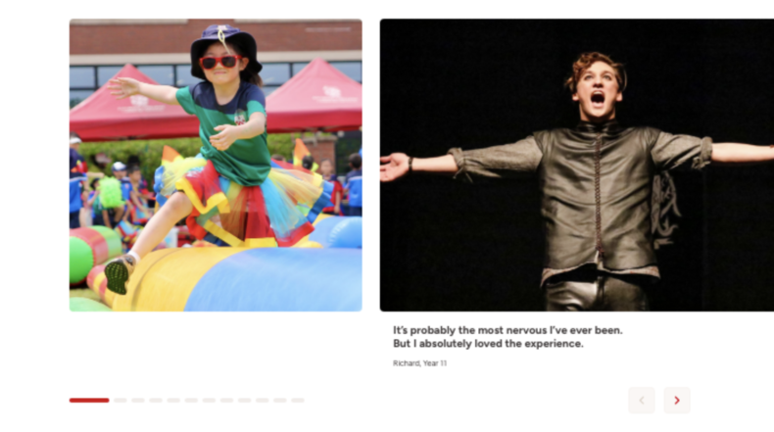

Content needed for community scroller:
No. | Student Name | Image (The student should be in the middle of the photo) | Short quote (15-35 words)
1. | Eshan B, Y13 | Hi-res image, 1920 x 1080 | Let your passion lead the way, and your heart will take you there. I’m thankful for all teachers who have played a huge role in shaping me as a musician.
2. | Nicholas Y, Y13 | Hi-res image, 1920 x 1080 | Dulwich is like a second home to me. It's truly grateful in such a beautiful and friendly environment.
3. | Yuva M, Y12 | Hi-res image, 1920 x 1080 | In my role as the new Head prefect of academics, my mission is to create an academic community that is supportive, inclusive and allows students to achieve the best of their capabilities.
4. | Jonathan S, Y4 | Hi-res image, 1920 x 1080 | My CCA favorite subjects are gymnastics, orchestra and mathematics, because they all use my mind to work a lot.
5. | Adela F, Y6 | Hi-res image, 1920 x 1080 | As JS head prefect, Adela said: ‘Leadership is not about being above others, but treating everyone equally and guiding others to success. You can approach us at any time, and we will do our best to listen to you with respect and pay attention to you.’
6. | Liam J, Y2 | Hi-res image, 1920 x 1080 | My teacher helps me and encourages me.

